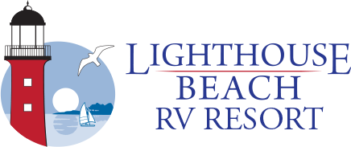
Site Improvement
Request Form

Name: ________________________________ Date: ____________________
Phone #: __________________ Site#: ____________________
Site Address: ________________________
. Millsboro, DE 19966 .
Please complete the above information. Use the space below to submit a drawing of the proposed improvements you intend to make on your site. Be sure to include labels & correct measurements. Sheds must be constructed of wood and may be a maximum of 64 sqft. No stick built sheds. Ground level decks, gazebos, firepits, gravel, and many other improvement ideas do not require a permit, however, any and all planned developments must first receive resort approval via completion of this form. Absolutely no concrete or concrete type substances may be used in the ground
PER SUSSEX COUNTY CODES, SHEDS MUST HAVE (2) FLOOD VENTS TOTALLING 80” LOCATED ON EACH BOTTOM SIDE OF THE SHED TO ALLOW WATER DISPURSEMENT AND IT MUST BE ANCHORED DOWN WITH A SHED ANCHOR KIT.
*Before digging on your site, the office must identify the existence/location of any water, sewer, electric and cable lines.

Not Approved: ________________ Date: ___________
Reason: ______________________________________
_____________________________________________

APPROVED: __________________________________
Lighthouse Beach RV Resort
DATE: ________________________________________

